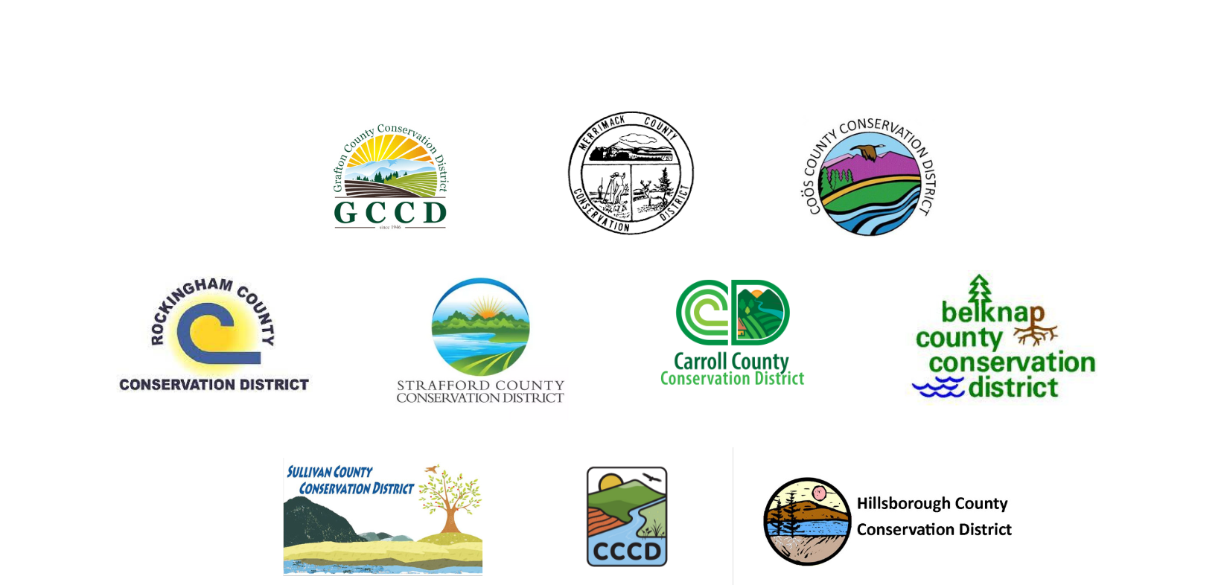
2023 NH Conservation Districts Climate Resilience Grant Final Report

At the conclusion of your project please complete this form and submit as an electronic file to request final 50% of payment and close the grant. Please note that districts will check in regarding project outcomes periodically following the submission of the final report. Please submit to the Conservation District by December 31st, 2024: mail to SCCD 95 County Farm Rd. Unity, NH 03743 or email ddextraze@sullivancountynh.gov

Project Title:

Final 50% Payment Requested:

Contact Information
Your Name:
Business or Organization Name:
Mailing Address: State: Zip:
Phone Number:
Email:

Project Description

Please provide an overview of the work completed with the Climate Resilience grant dollars. This must include the following: tasks accomplished, unanticipated challenges, project results, and a description of any education and outreach offered as a result of this project.

Project Impact

Please provide a detailed overview of how the work completed with the Climate Resilience grant dollars helped your farm better mitigate and/or adapt to climate change and become a more viable business. Please include any anecdotal (less flooding before or after project, etc.) and relevant collected data (examples include but are not limited to: soil carbon data, pesticide usage (before and after project), yields (before and after project), farm profitability (before and after project), energy use (before and after project), water use (before and after project), etc. These metrics are critical to show the impact of the funding and ensure we can keep providing these grants to farms in NH.
Testimonial

Please provide a testimonial that speaks to the impact the Climate Resilience grant has had on your farm business. This quote may be used in outreach for the grant, providing it here gives the conservation districts permission to use it. The conservation districts may contact you for further information.

Required Attachments

- Photograph (digital jpg format) of farm family or crew in front of the completed project with provided Climate Resilience Grant Banner. Please contact your conservation district to secure the banner for the photo. (Please note that photo is not due at time of report, but a time for the photo must be determined).
- Photographs that demonstrate the process and completion of the project
- Invoices & receipts, the total of the invoices & receipts should match the total grant fund and match (please note time can be used as in kind match). Please provide explanation and the “in kind contribution tracking” form as necessary.
- Information on the metrics identified in application Reports or other documents created with these funds.

