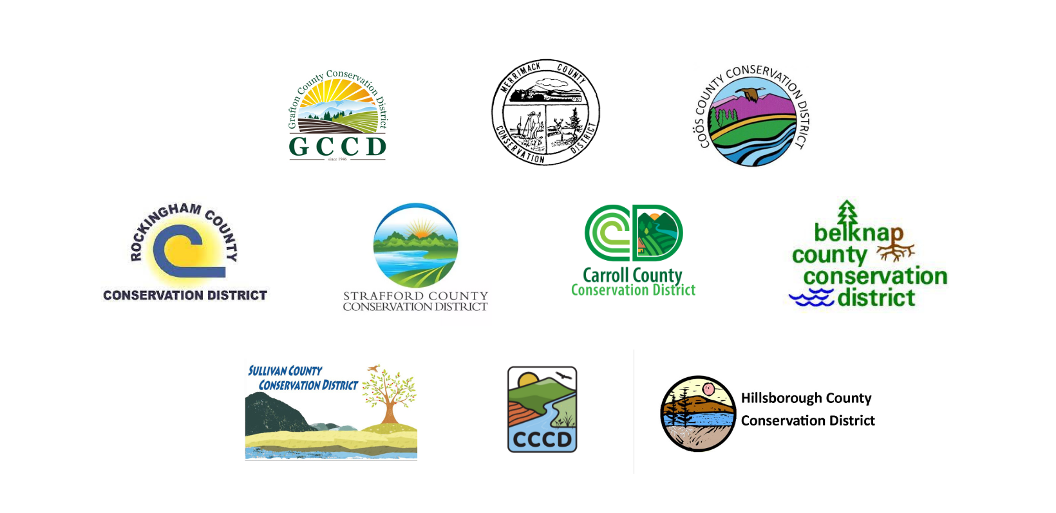
NH Conservation Districts Climate Resilience Grant

Partnership Form
for Technical Assistance Providers

Please work with your Technical Assistance Provider to complete and submit this Partnership Form with your Grant Application to your County Conservation District by February 1, 2024.

Farm Name:

Technical Assistance Provider Information

Name:

Title: Organization:

Phone: Email:

Role of Technical Assistance Provider in this Project
Please provide information on how the Technical Assistance Provider will be involved with this grant ‘project if selected for funding. Please consider planning, implementation, and tracking metrics of success.

Signature of Technical Assistance Provider: ______________________________________

Date: ____________________

